Project Design Phase - Proposed Solution Template
Date | 11 August 2026
Team ID | N/A
Author / Team Member | Aditya Kamble
Project Name | ShopEZ Ecommerce Application
Maximum Marks | 2 Marks

Sr.No. | Parameter | Description / Implementation in ShopEZ
1 | Problem Statement | Online shoppers struggle with slow, bloated e-commerce portals with clunky checkout flows, while small sellers lack lightweight tools for real-time inventory and order fulfillment.
2 | Proposed Solution | ShopEZ: A modern, full-stack MERN e-commerce application created by Aditya Kamble offering an intuitive storefront, instant cart calculations, streamlined checkout, and an integrated Seller/Admin Dashboard with inline stock editing and revenue analytics.
3 | Target Users | 1. Retail Shoppers (browsing, purchasing, and tracking orders)  2. Sellers / Merchants (managing product catalogs, stock levels, and pricing)  3. Platform Administrators (managing system users, settings, and orders).
4 | Core Value Proposition | Fast single-page shopping experience with zero clutter, combined with seller empowerment through automated low-stock warnings and inline catalog updates.
5 | Key Competitive Differentiators | • Integrated Seller Central with inline editing without page reloads  • Automatic low-stock warning threshold (< 10 units)  • Clean MERN MVC architecture with Multer image uploads and JWT security  • Seamless Cash on Delivery (COD) ordering.

Proposed Solution Architecture Overview:

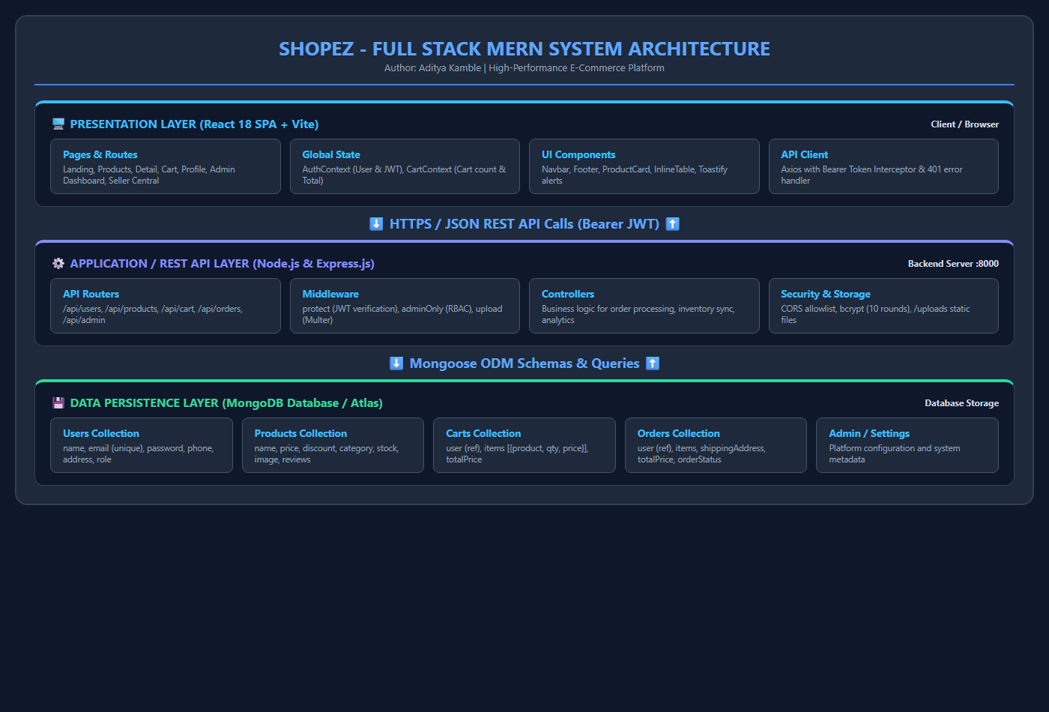
Figure 7: Proposed System Architecture Overview

